SEC Form 3
FORM 3 | UNITED STATES SECURITIES AND EXCHANGE COMMISSION
 | Washington, D.C. 20549
 | Washington, D.C. 20549 |  | OMB APPROVAL
 | INITIAL STATEMENT OF BENEFICIAL OWNERSHIP OF SECURITIES
 | INITIAL STATEMENT OF BENEFICIAL OWNERSHIP OF SECURITIES |  | OMB Number: | 3235-0104
 |  |  | Estimated average burden
 | Filed pursuant to Section 16(a) of the Securities Exchange Act of 1934 |  | hours per response: | 0.5
or Section 30(h) of the Investment Company Act of 1940
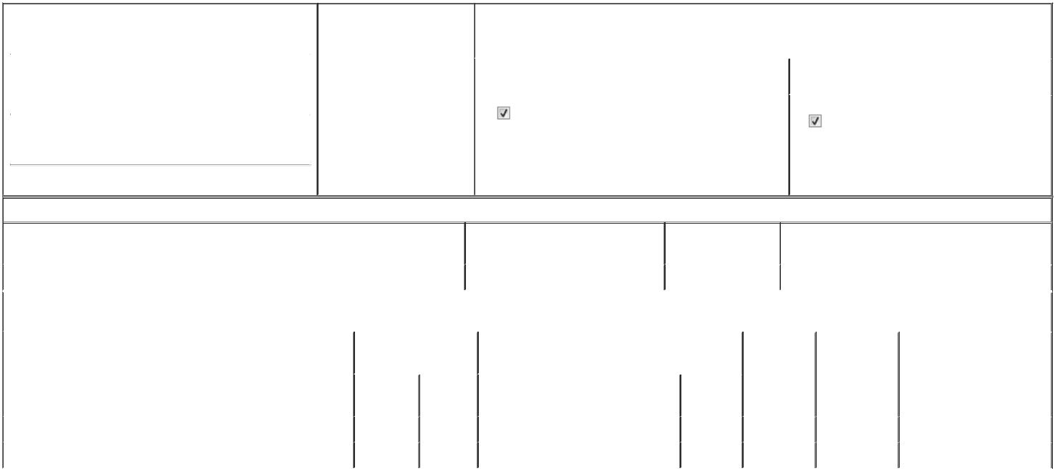

1. Name and Address of Reporting Person* |  |  |  |  |  | 2. Date of Event Requiring
 |  | GREEN ANDREW M |  |  |  | Statement (Month/Day/Year)
 |  |  |  |  | 06/01/2026
 |  | (Last) | (First) |  | (Middle)
 |  | 1655 ROBERTS BLVD., NW
(Street)
 |  | KENNESAW | GA |  | 30144

3. |  | Issuer Name and Ticker or Trading Symbol
ARTIVION, INC. [ AORT ]
4. |  | Relationship of Reporting Person(s) to Issuer |  |  | 5. | If Amendment, Date of Original Filed (Month/Day/Year)
(Check all applicable)
 |  | Director |  | 10% Owner
 |  |  |  | 10% Owner | 6. | Individual or Joint/Group Filing (Check Applicable Line)
 |  | Officer (give title |  | Other (specify below) | 6. | Individual or Joint/Group Filing (Check Applicable Line)
 |  | below) |  | Other (specify below) |  | Form filed by One Reporting Person
 |  | SVP, Regulatory and Quality |  |  |  | Form filed by More than One Reporting Person

(City) (State) (Zip)

Table I - Non-Derivative Securities Beneficially Owned

1. Title of Security (Instr. 4) | 2. Amount of Securities Beneficially | 3. Ownership Form: | 4. Nature of Indirect Beneficial Ownership (Instr. 5)
 | Owned (Instr. 4) | Direct (D) or Indirect
 |  | (I) (Instr. 5)

 | Common Stock |  |  |  | 60,259⁽¹⁾ | D
 |  |  | Table II - Derivative Securities Beneficially Owned
 |  | (e.g., puts, calls, warrants, options, convertible securities)
 | 1. Title of Derivative Security (Instr. 4) |  | 2. Date Exercisable and |  | 3. Title and Amount of Securities Underlying |  |  | 4. | 5. Ownership |  | 6. Nature of Indirect Beneficial
 |  |  | Expiration Date |  | Derivative Security (Instr. 4) |  |  | Conversion | Form: Direct |  | Ownership (Instr. 5)
 |  |  | (Month/Day/Year) |  |  |  |  | or Exercise | (D) or Indirect
 |  |  |  |  |  |  |  | Price of | (I) (Instr. 5)
 |  |  |  |  |  | Amount or |  | Price of
 |  |  |  |  |  |  |  | Derivative
 |  |  | Date | Expiration | Title | Number of |  | Security
 |  |  | Exercisable | Date | Title | Shares
 | Stock Options (Right to buy) | (2) |  | 02/23/2029 | Common Stock | 14,001 |  | 18.44 |  | D
 | Stock Options (Right to buy) | (2) |  | 11/08/2029 | Common Stock | 30,000 |  | 11.03 |  | D
 | Explanation of Responses:
 | 1. Includes 41,529 restricted stock units that represent a contingent right to receive one share of the issuer's common stock for each unit.
 | 2. The option is fully vested and immediately exercisable.
 | Remarks:
 | Exhibit 24 - Power of Attorney
 |  |  |  |  |  | /s/ Andrew M. Green |  |  |  | 06/08/2026
 |  |  |  |  |  | ** Signature of Reporting Person |  |  | Date
 | Reminder: Report on a separate line for each class of securities beneficially owned directly or indirectly.
 | * If the form is filed by more than one reporting person, see Instruction 5 (b)(v).

** Intentional misstatements or omissions of facts constitute Federal Criminal Violations See 18 U.S.C. 1001 and 15 U.S.C. 78ff(a).

Note: File three copies of this Form, one of which must be manually signed. If space is insufficient, see Instruction 6 for procedure.

Persons who respond to the collection of information contained in this form are not required to respond unless the form displays a currently valid OMB Number.



